

Date:
ShipSure 2.0 - Crewing Release Notes – Office 2.0.27.806
Author: r

New Features/Changes

Key | Sumary | Module
37304 | Line Up Performance Issues | Lineup
36027 | Lineup Add Crew Screen - Performance - Multiple | Lineup
37311 | Crew lineup Screen Changes: Space Allocation on Splitter Should be 50/50 | Lineup
36420 | Document & Certificate : Screen Performance improvement | Personal Details
37313 | PD - Mobilisation Task - Add Document Column | Personal Details
36810 | Employee ID | Personal Details
25424 | ShipSure - Seafarer App Last Login Date | Personal Details
34995 | Working List Screen Changes | Working List
8542 | Mobilisation Checklist Sections - Crew Assignment Details | Mobilisation Checklist
8543 | Crew Mobilisation Checklist - ShipSure Data based checks | Mobilisation Checklist
8544 | Crew Mobilisation Checklist - Manual Check Items based on templates | Mobilisation Checklist
8545 | Crew Mobilisation Checklist - Checklist History Tab | Mobilisation Checklist
15914 | Crew Mobilsiation Checklist - Screen and DB Structure | Mobilisation Checklist
39451 | Mobilisation Checklist: Re-open checklist functionality for Admin is required (Security Driven) | Mobilisation Checklist
39475 | MO Checklist - Accepted by and Accepted on details not getting displayed just after successfully update Mobilisation details | Mobilisation Checklist
39453 | Mobilisation Checklist - Capture logs | Mobilisation Checklist
39455 | Crew Change - Save Left Home / Arrived Home dates as Wage Start / End dates for Onboard record | Crew Change
37340 | Crew Change Performance Improvement | Crew Change
35363 | Crew List - Add Supply Type icons for Onboard crew and Relievers | Crew List
35933 | Approved functionality through mobile app by accepting NAN | Mobilisation Overview
29904 | New Icons for Crewing (All tabs) | System
29423 | Task Manager: Turn Off Notification Status | Task Manager

37304 - Line Up Performance Issues
Performance of loading Add Crew form has been improved by removing following columns.
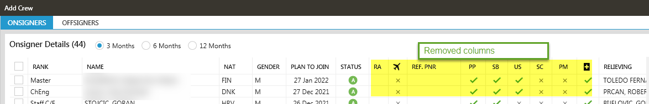

36027 - Lineup Add Crew Screen - Performance - Multiple
PCN and Seafarer status columns have been added in the Line Up crew list grid.
By double clicking on the travel columns (Hotel, Transport, Flight) it will open Edit Travel details tab.
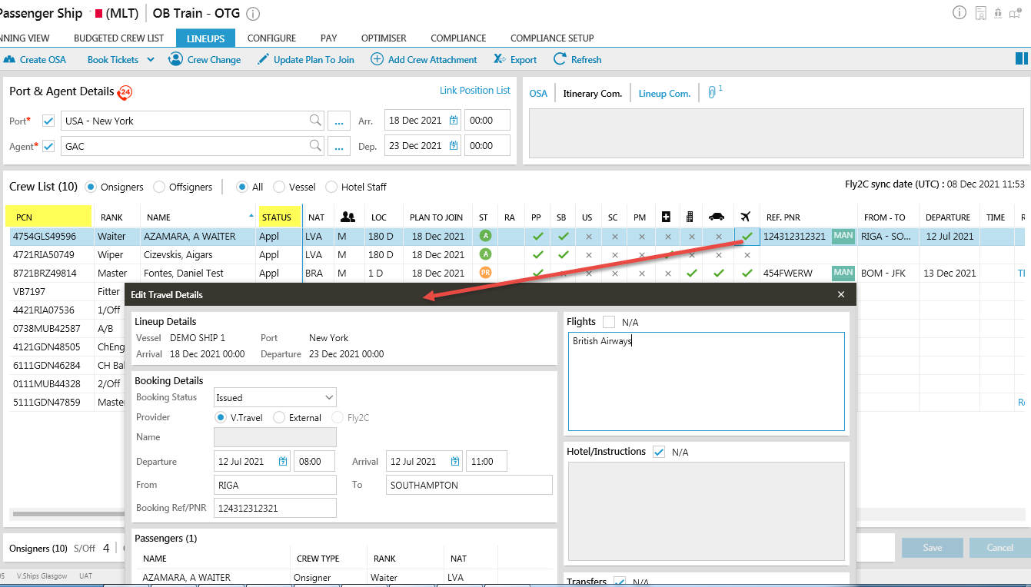
A new SP has been created to fetch records in Add Crew functionality on Lineup screen. Only columns related to crew have been retained. PCN and Current status has been added as a column.
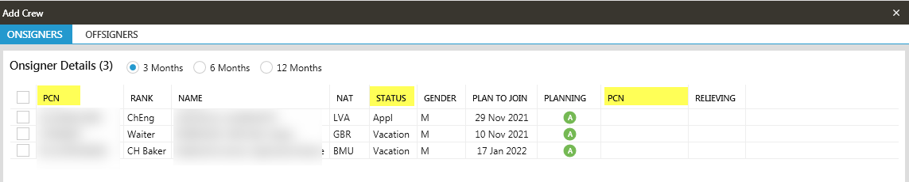

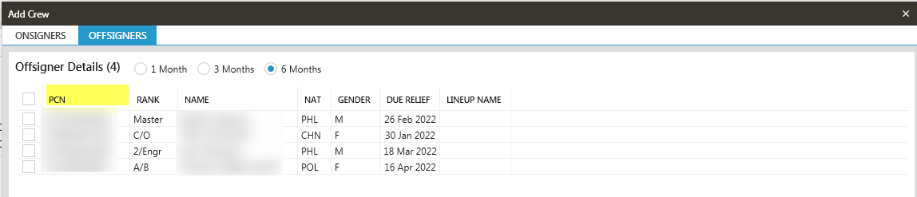
37311 - Crew lineup Screen Changes: Space Allocation on Splitter Should be 50/50
Space Allocation on Splitter changed to 50/50.
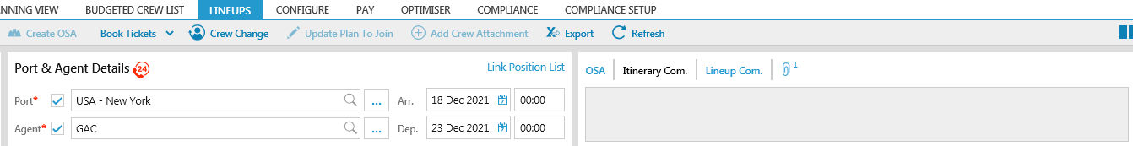

8542 – Seafarer App Last Login Date

Add a new line in the summary screen of personal details to show the days since the seafarer last logged in. this comes from APIClientLog.This shall show the most recent date since login.
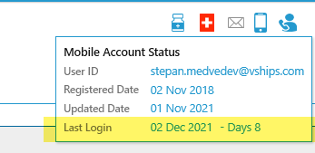

36810 Employee ID
Additional field has been added to store seafarer’s employee ID. This is to store Owner specific crew ID in case Owners have a separate system and id for seafarer. This is also used to store old crew ID in case the data has been migrated from another system.
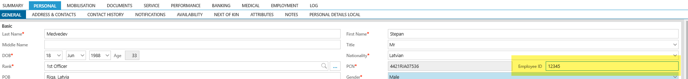

36420 Document & Certificate : Screen Performance improvement
Add / Edit document form performance has been improved. No longer process attached files without a need.

37313 PD - Mobilization Task - Add Document Column
Document columns has been brought back into Crew mobilization tasks screen.

34995 - Working List Screen Changes
Following changes for Work List function have been implemented:
- Add to WL button function has been split into two: "Add to Std. WL", "Add to Mob. WL" in the below screens to avoid multiple clicks by user
a. Crew Search
b. Plan reliever
c. Mobilisation overview - Accepted Approved
d. Gantt View - In Progress

- Crew list - Still shows pop-up to select type as agreed on the call
- Plan reliever - Known Reliever - shows crew from Standard working list only
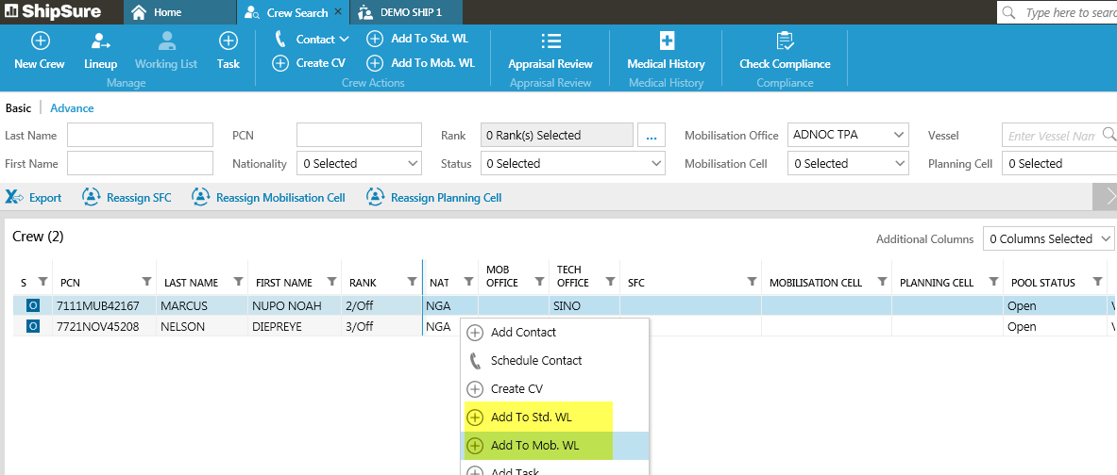

8542 - Mobilization Checklist Sections - Crew Assignment Details
Notification in Tasks on status "Completed" has been removed.
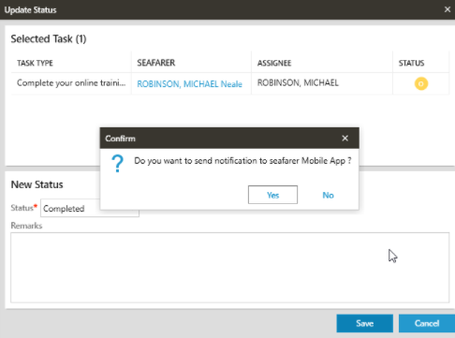

8542 - Mobilization Checklist Sections - Crew Assignment Details
A new tab called “Mobilisation Checklist” has been added in a Seafarer Profile/ Mobilisation tab. This tab displays details of Seafarer’s Next Assignments and Approval Acceptance Data.
- In the checklist form, added a section to show the assignment details and mobilisation approval acceptance details
Assignment Details - Data will be displayed when a seafarer has an active future assignment.
  - Status
  - Vessel
  - Budgeted Rank
  - Joining Date
  - LOC
  - Created On
  - Created By
Approval Acceptance - Data shall be displayed when Crew Assignment is Approved.
  - Est. Readiness - Should Be Editable
  - Resp. for Mobilisation - Should Be Editable
  - Accepted on
  - Accepted by
  - Approved on
  - Approved by
  - Plan Cell
  - Plan Cell Manager
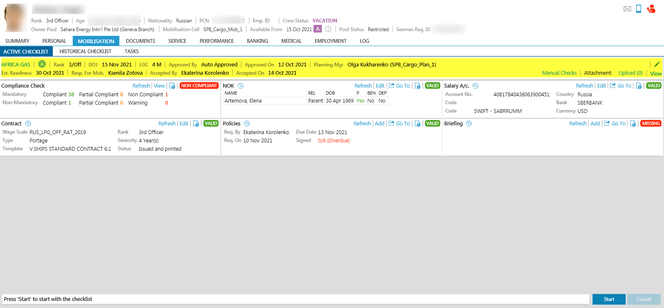
- User can edit the details of estimated readiness and responsible for mobilisation from this section. The list of users comes up from Seafarer’s Mobilisation Cell users.
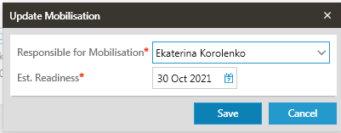
- User can also navigate through different service records and create a checklist
- Attachments can be added to each checklist

8543 - Crew Mobilisation Checklist - ShipSure Data based checks
The Mobilisation Checklist is built of below sections for the checks to be performed
- Compliance
- NOK
- Policies
- Briefing
- Contract
- Salary account
- Housing & health insurance (For Filipino Crew Only)
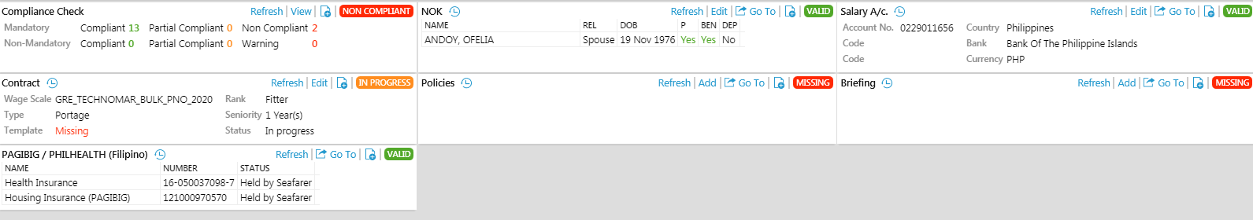

8544 - Crew Mobilisation Checklist - Manual Check Items based on templates
Manual Checklist section displays Checklist tasks that are not based on Shipsure Data and a completed manually by the user upon confirming the requirement/task. The requirements in this section will have General tasks as well as ones based on nationality or other criteria such as Owner.

- Added an option to configure the templates against the vessel
- While creating the checklist, the mapped templates against the vessel will appear as pre-selected items in the list
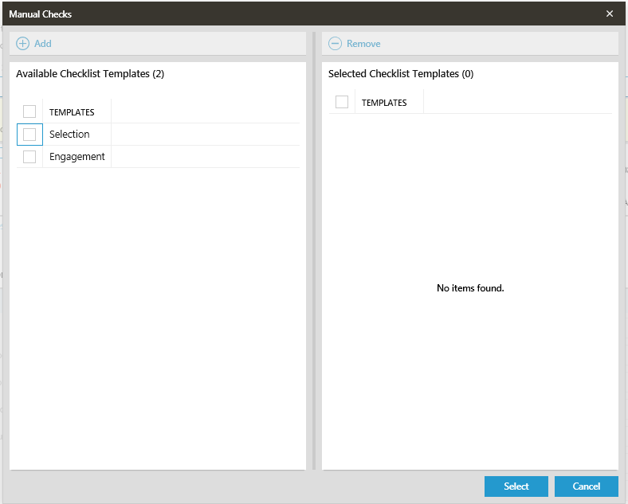

- User can answer against each of the question
- If all the questions are not answered then an indication in red icon will appear to highlight the same
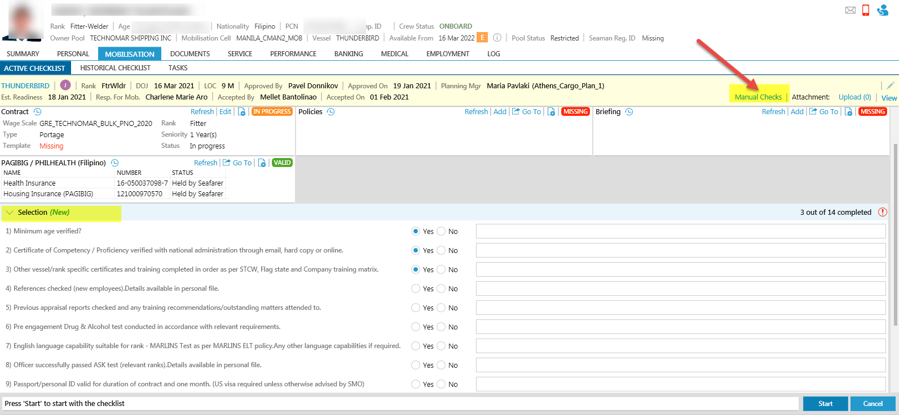

8545 - Crew Mobilisation Checklist - Checklist History Tab
Mobilisation tab has now a new Checklist History tab to view the list of historical checklist
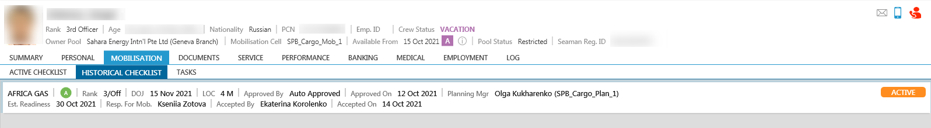

15914 - Crew Mobilsiation Checklist - Screen and DB Structure
- A separate tab added for the Active Checklist Screen where user can work on the next assignment checklist
- User can also switch between the assignments in case of multiple assignment
- After the selection of assignment, user can hit the start button to start working on the checklist
- User can also upload or download documents against the checklist
- Once the data is verified, user can hit "Approve & Sign" button to sign the checklist

39451 - Mobilisation Checklist: Re-open checklist functionality for Admin is required (Security Driven)
User can re-open the checklist even after it is signed off by the user. This functionality is security driven

39453 - Mobilisation Checklist - Capture logs
The logs (database) are captured for the following actions performed by the user
- When a checklist is started or created
- When a checklist is modified
- When a checklist is signed
- When a checklist is re-opened

37340 Crew Change Performance Improvement
Load time of crew change form has been improved by removing crew pictures and unnecessary checks. The form should now be handling big crew change better.

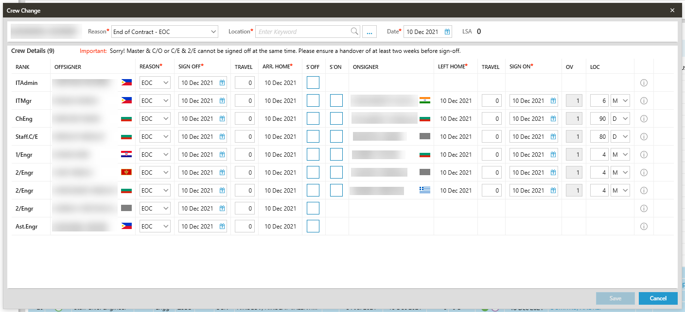

39455 - Crew Change - Save Left Home / Arrived Home dates as Wage Start / End dates for Onboard record

In the previous system version, there was a discrepancy in a proper saving of Wage Start/End dates for Onboard service when crew change was done. When there were travel days, the Left/ Arrived home dates were saved against Transit Record. This logic of saving actual sign on/off dates as wage start /end resulted in discrepancies in payment calculations and is a problem for APS team.

Now updating of Wage Start date and wage end date for OB records is as per Left Home and Arrived home dates i.e. based on Travel days.

35363 Crew List - Add Supply Type icons for Onboard crew and Relievers
Icons for TPA and Owner supplied crew has been added to crew list onboard crew and relievers.
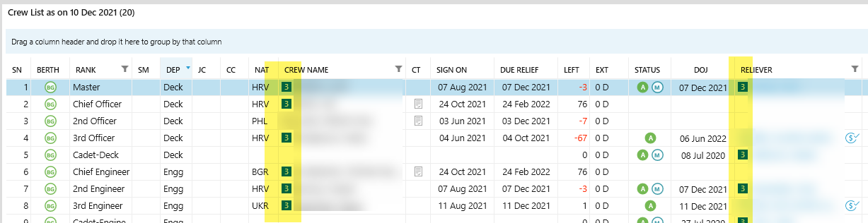

29904 New Icons for Crewing (All tabs)
Open tab icons have been changed for crewing modules to be more recognizable.

BUG FIXES:
35933 - Approved functionality through mobile app by accepting NAN
The bug appearing in Awaiting Acceptance Screen has been fixed.
- Marked crew had Mobilisation Cell details displayed in the Planning Cell Columns,
- If no planning cell available for crew (Crew accept the NAN) - then this should be blank now.
